# Take-Home Quiz # 2

**(Sections 5.1 – 5.4)**

## Math 141/6380, Due 11:59PM, Sunday, June 11, 2017

**Instructions:** This quiz must be completed independently. You are allowed to consult with your notes or the textbook as needed to aid you in solving these problems. Seeking help from others in or out of the class is not allowed.

Suggestions about how to approach this quiz:

1. Finish all homework assignments of the sections and get good understanding of the contents from the last week.
2. Print out a copy of the quiz and solve any problems that you can, using pencil and paper.
3. Review the eBook sections associated with any problems you could not solve.
4. Complete the remaining problems to the best of your ability. Even if you cannot come to a final solution, you should show what you do know so that you have the opportunity for partial credit.
5. Review your work. Check for errors. Make sure you have included units where appropriate, and explanations when required by the instructions.Unless the problem explicitly states otherwise, work must be shown for every answer. Any answer, even if “correct” but lacking work, will NOT receive full credit and may receive NO credit!
6. When you are satisfied, type in your solutions (**extend space if needed**) or scan your hand written work or take photos with your camera. Make sure that your submission is readable.
7. Submit your work in the associated LEO assignment.

**Unless the problem explicitly states otherwise, work must be shown for every answer. Any answer, even if “correct” but lacking work, will NOT receive full credit and may receive NO credit!**

Please submit the quiz as an attachment in any readable formats such as scanned or photo copy before or on Sunday, June 11. **No late quiz will be accepted. No make-up quiz will be arranged**. A solution key for Quiz # 2 will be posted along with the quiz right after the deadline.

|  |
| --- |
| **Please sign (or type) your name below the following honor pledge:**  **I have completed this quiz by myself, working independently and not consulting anyone except the instructor. I have neither given nor received help on this quiz.**  **No calculator is allowed in solving the definite integrals in this quiz. Leave answers involving irrational numbers as is. Do not use calculator estimations.**  **Name _____________________ Date___________________** |

# QUIZ # 2 Problems

(An answer, even if “correct” but lacking work, will NOT receive full credit!)

1. The area enclosed between $y=x^{2}+2$ and $y=3$ is revolved about the horizontal line $y=3$ to form a solid. Calculate the volume. (Hint: Disks)

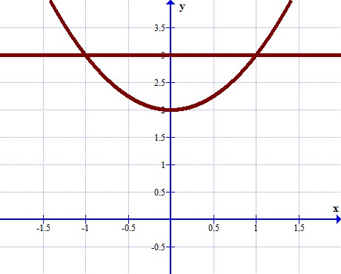

2. Let **R** be the region between the graphs of *f* (*x*) and *g*(*x*) on the given interval. Find the volume **V** of the solid obtained by revolving **R** about the ***x-* axis**, where

 and   [0, 4]. （Hint: Solids with Holes）

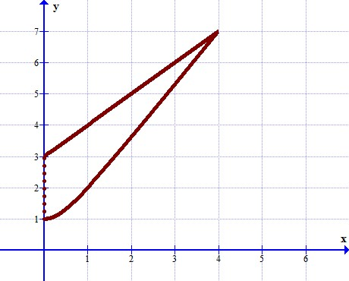

3. Find the arc length of the curve  over the interval [1, 8]

4. Find the length of the curve from *y* = 0 to *y* = 3

5. Find the area of the surface generated by revolving about the *x*-axis the curve on .

6. Find the area of the surface generated by revolving about the *x-*axis the curve on .

7. Suppose that a spring has a natural length of 10 ft and that a weight of 100 lb is required to hold it compressed to a total length of 6 ft. How much work is required to stretch the spring from a total length of 15 ft to 25 ft?

10 ft 15ft 25ft

*x = 0 x = 5 x = 15*

8. Find , **centroid of the region** of constant density *k* covering the region bounded by the parabola and the line . (Hint: Find the intersections first, then find $M, \overline{x} and \overline{y}, respectively$).

